IDEAL
Pi Theta Epsilon strives to instill in its members the ideal of respect for learning, and commitment to scholarship throughout one’s professional life.
By inviting you to join us, we have conferred upon you an honor and an obligation.
The honor is in recognition of your integrity, your high standards of scholarship, and the promise of your future as one of achievement.
In accepting the invitation to become a member of this honor society you have taken upon yourself the obligation to devote your efforts to the advancement of Occupational Therapy, through scholarship and research, and to the maintenance of the high standards of Pi Theta Epsilon.
We are completing the requirements of an education. We are learning how to learn. The real education is just beginning…the application and broadening of knowledge…testing our interest and diligence in our work. We are challenged today and in every coming day to go beyond the requirements of an education, to continue to learn for the knowledge and growth it brings to us, and to help others meet their needs to the best of our abilities. Excellence in purpose and scholarship is the key to opportunity and carries with it vast rewards to others and ourselves. This honor society, Pi Theta Epsilon, challenges us for excellence.

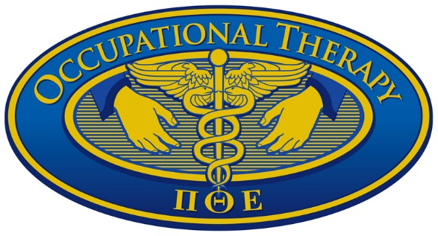

Pi Theta Epsilon
National Occupational Therapy Honor Society
________________________________
Alpha Iota Chapter
Creighton University

Induction Ceremony
November 22, 2009
Harper Center Ballroom
Creighton University

PROGRAM
Welcome………………....... [Insert Name], (Faculty Advisor, Alpha Iota Chapter, Pi Theta Epsilon
Blessing………………........ [Insert Name], Chaplain (Campus Ministry)
Inspirational Message..........[Insert Name], (Title)
By appearing before us, you have signified your desire to become a member of Pi Theta Epsilon. Each of you should understand fully the meaning of its name, its purpose, and its ideal.
NAME
PI, is the first letter in the Greek word for advancement
THETA, is the first letter in the Greek word for therapeutic
EPSILON, is the first letter in the Greek word for occupation.
Therefore, Pi Theta Epsilon stands for advancement in Occupational Therapy.
PURPOSE
The purposes of the honor society shall be:
- To recognize and encourage scholastic excellence in occupational therapy students.
- To contribute to the advancement of the field of occupational therapy through scholarly activities.
- To provide a vehicle for professional, entry-level students enrolled in accredited programs in occupational therapy to exchange information and to collaborate regarding scholarly activities.

PI THETA EPSILON PLEDGE
“Aware of the high calling of the scholar and the great opportunity of service through Occupational Therapy, I hereby pledge my efforts to further its purposes, to uphold the ideal of Pi Theta Epsilon, and to prove myself a worthy member of this honor society.”
As each name is called, each new member will come forward for signing of the membership book and the lighting of the candles.
[Insert List of New Members Here]
You have repeated the words of a pledge.
The honor of this pledge is held within you.
You can carelessly toss it aside or you can make it a meaningful part of your studies and outside activities. What you decide will influence the other members of your honor society and others outside your honor society. It becomes then your responsibility to integrate the pledge you have taken and fulfill the goals as you are able. In this way the integrity of this organization, members past and present and Occupational Therapy itself will be strengthened and maintained. New initiates, welcome to the [Insert Name of university/chapter] Chapter of Pi Theta Epsilon.

